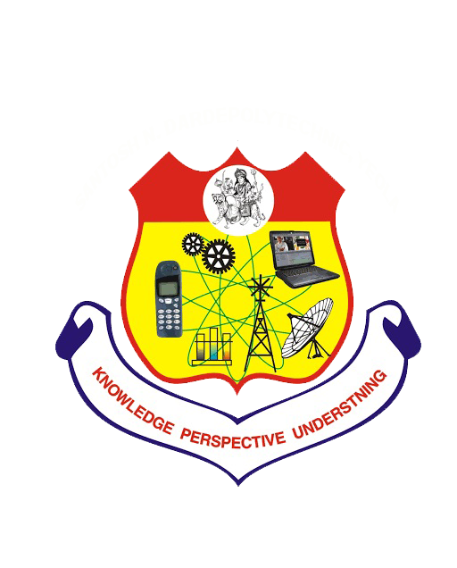

Jagdamba Education Society’s
S.N.D.Polytechnic, Yeola-423401
- Approved by AICTE, New Delhi and DTE Maharashtra
- Affliatedtp MSBTE, Maharashtra
- Phone: (02559)225002,225006 Email:sndpoly.com Fax02559)225032
Department of Electrical Engineering

NEWSLETTER

Chairman: Mr.Kishor Darade
Principal: Mr.Jadhav U.B.
HOD: Mr.Chavan.G.P
Teaching Faculties:
1) Mr.Kale.G.P
2) Mr.Yeole.S.S
3) Mr.Nikam.A.D
4) Mr.Kshirsagar R.N.
5) Mr.Wagh.K.B
6) Mr.Aher.R.D
7) Mr.Chavan.K.V
8) Ms.Kokate.M.C
9) Mr.Jaybhaye S.R

Non-Teaching Faculties:
1) Mr.Inagle.E.C
2) Mr.Khute Y.R
3)Mr.Gaikwad V.N.

- Mr.Thalkar S.R

From the Desk of Principal:
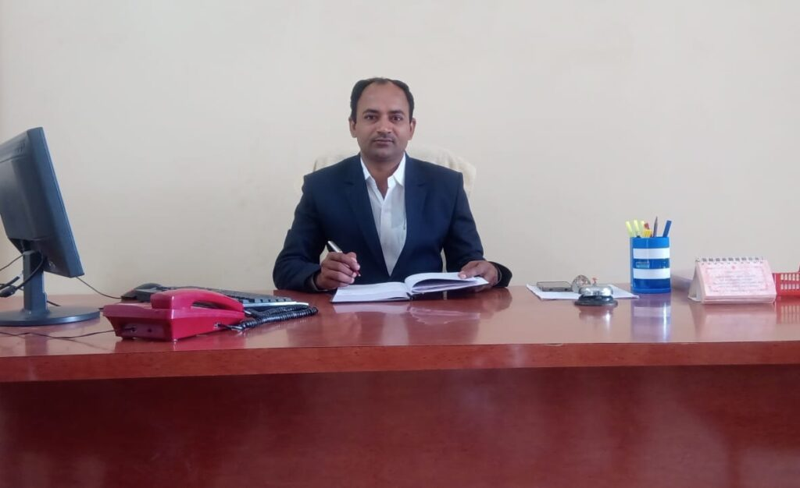
“We are happy to publish glory of Electrical Engineering Department through this newsletter for Acadmic Year 2021-22.”
-Prof.Jadhav U.B.
From the Desk of HOD: 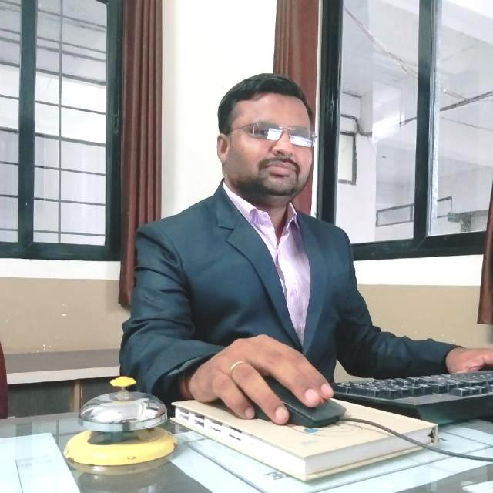
“It is pleasure to put forth the first edition of e-newsletter for the academic year 2021-2022. The newsletter details all the academic events and activities held by department.”
-Prof .Chavan .G.P (M. E. Power System)

Contact of Department:
Phone:02559/225007
Email-id: sndpolyee@gmail.com

VISION AND MISSION OF INSTITUTE

VISION OF THE INSTITUTE:
“To create and maintain learning environment to produce technocrats who will serve the society with their knowledge and skill.”
MISSION OF THE INSTITUTE:
- To shape future technocrats and sound knowledge and skill for private, public sector organizations and society.
- To strive to find cost effective and sustainable solutions in various disciplines of engineering to improve quality of life.
VISION AND MISSION OF DEPARTMENT

VISION OF THE DEPARTMENT:
“To promote the technical education and strive for the betterment of the society.”
MISSION OF THE DEPARTMENT:
- M1-To produce outstanding engineers with high technical knowledge to serve the society.
- M2-To impart value based education.
- M3-To produce solution to the challenges in the field of Electrical engineering.

PERSONALITY DEVELOPMENT PROGRAM

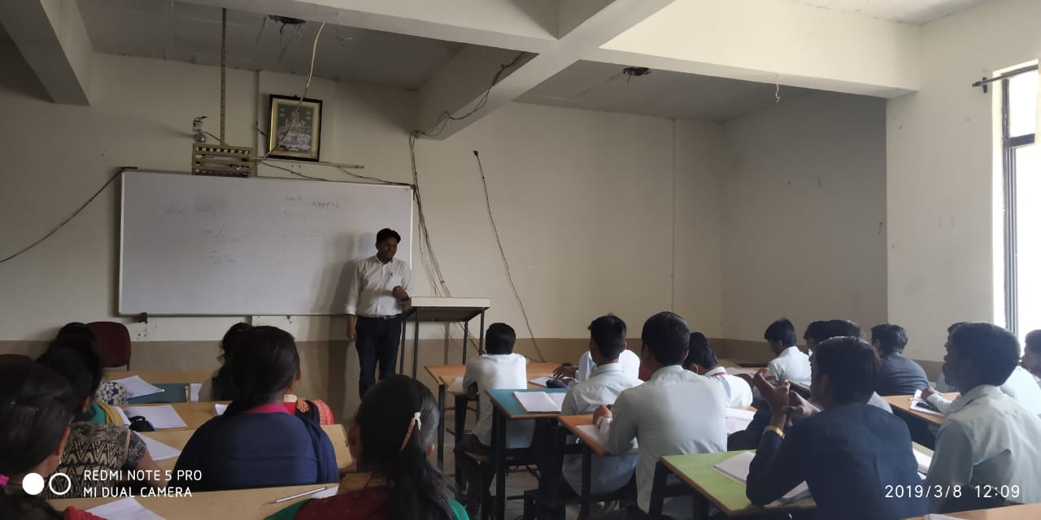
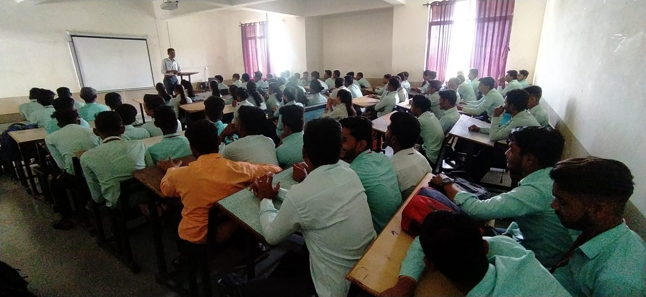

Mr.DEORE SAGAR was revarious aspects of personality development. Students of Third Year of Electrical Engineering and Second Year m
Mr.prashant kadam Guided to the TYEE Electrical Student on Industrial and agricultural automation

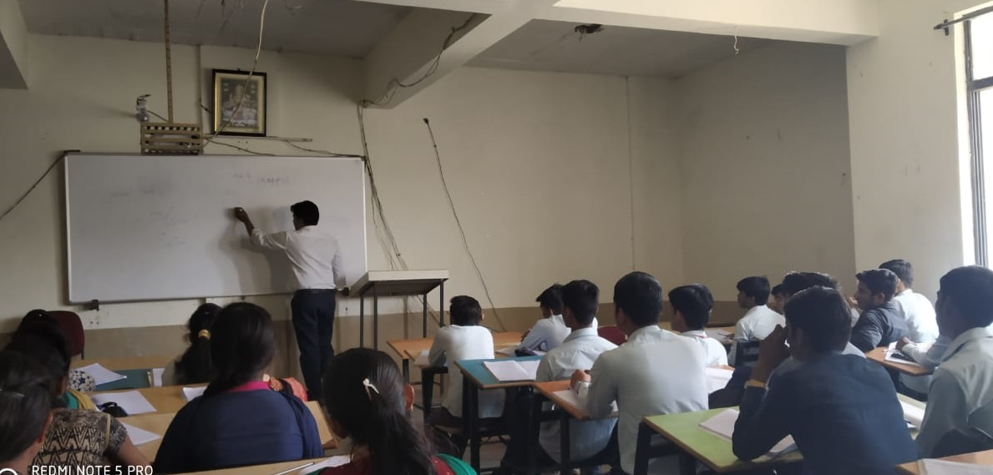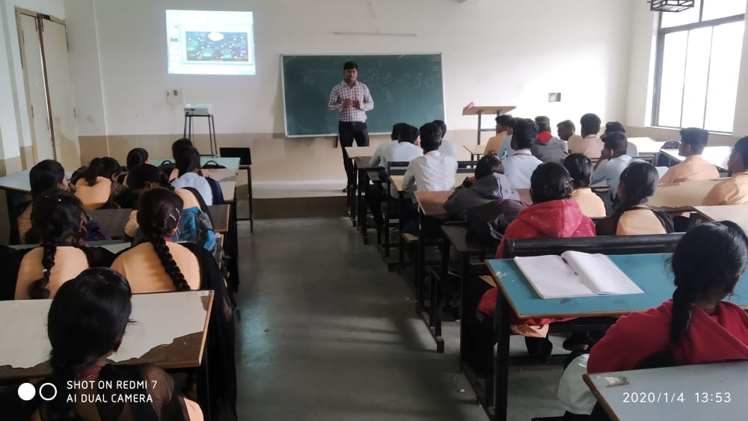

Mr.Amit solankhi guided to the TYEE Electrical student on Role of power electronics in renewable energy sources
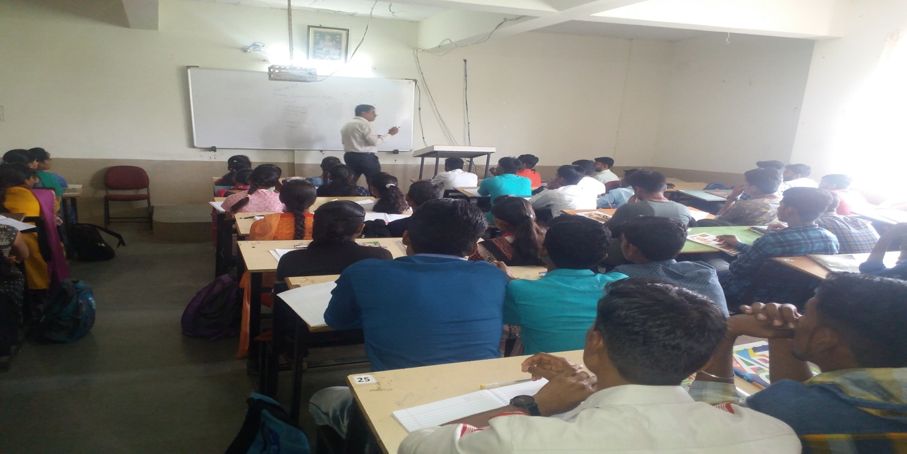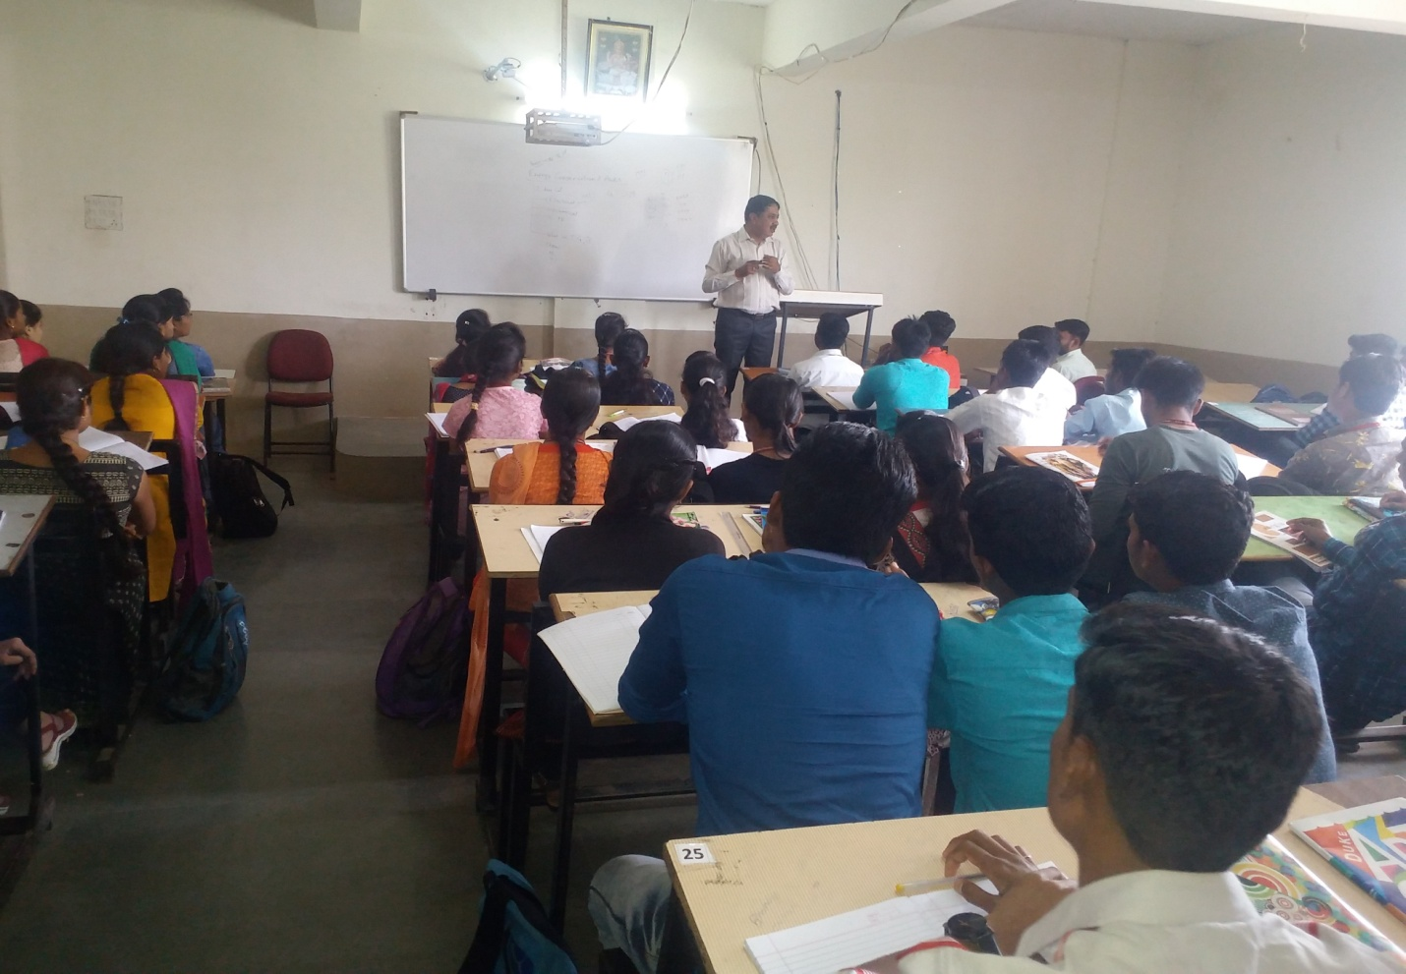

Mr.Sanjay P Gavade was gives the lecture of TYEE Stuedents on “NEED OF POWER FACTOR IMPROVEMENT”

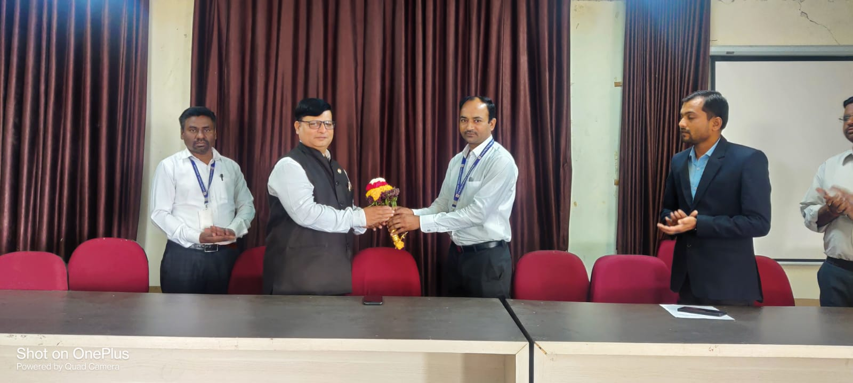

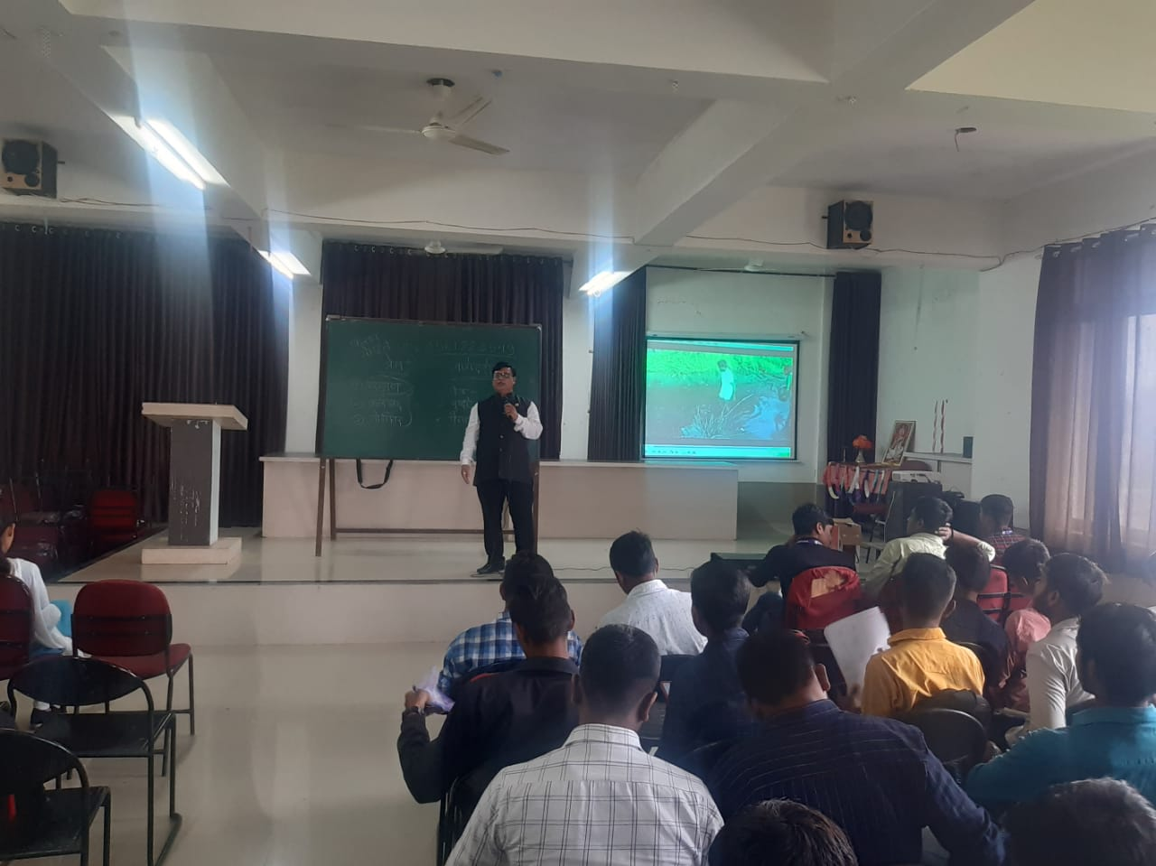
Expert lecture by Mr.Kiran Mohite to TYEE/SYEE Students

INDUSTRIAL SITE VISIT KOTAMGAON SUBSTATION

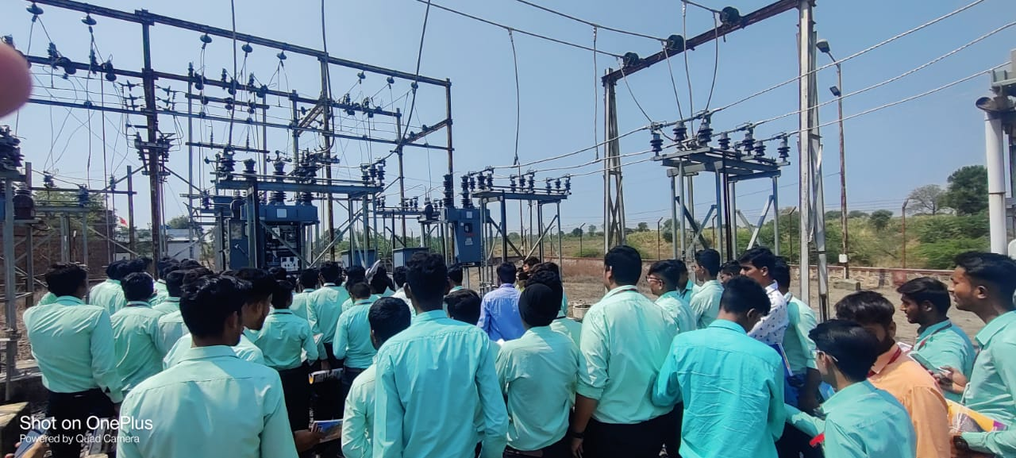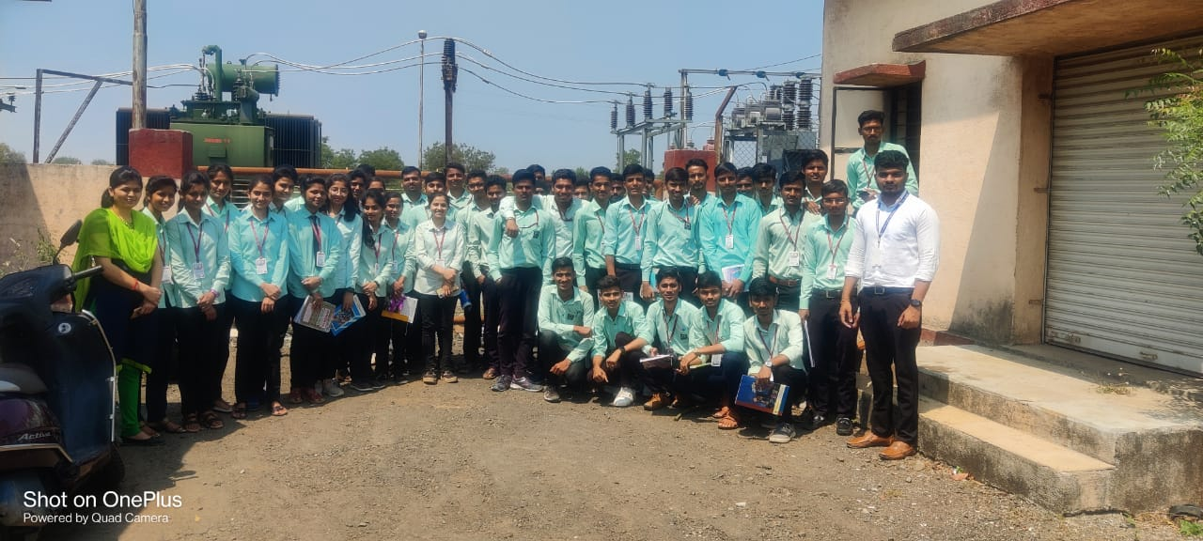
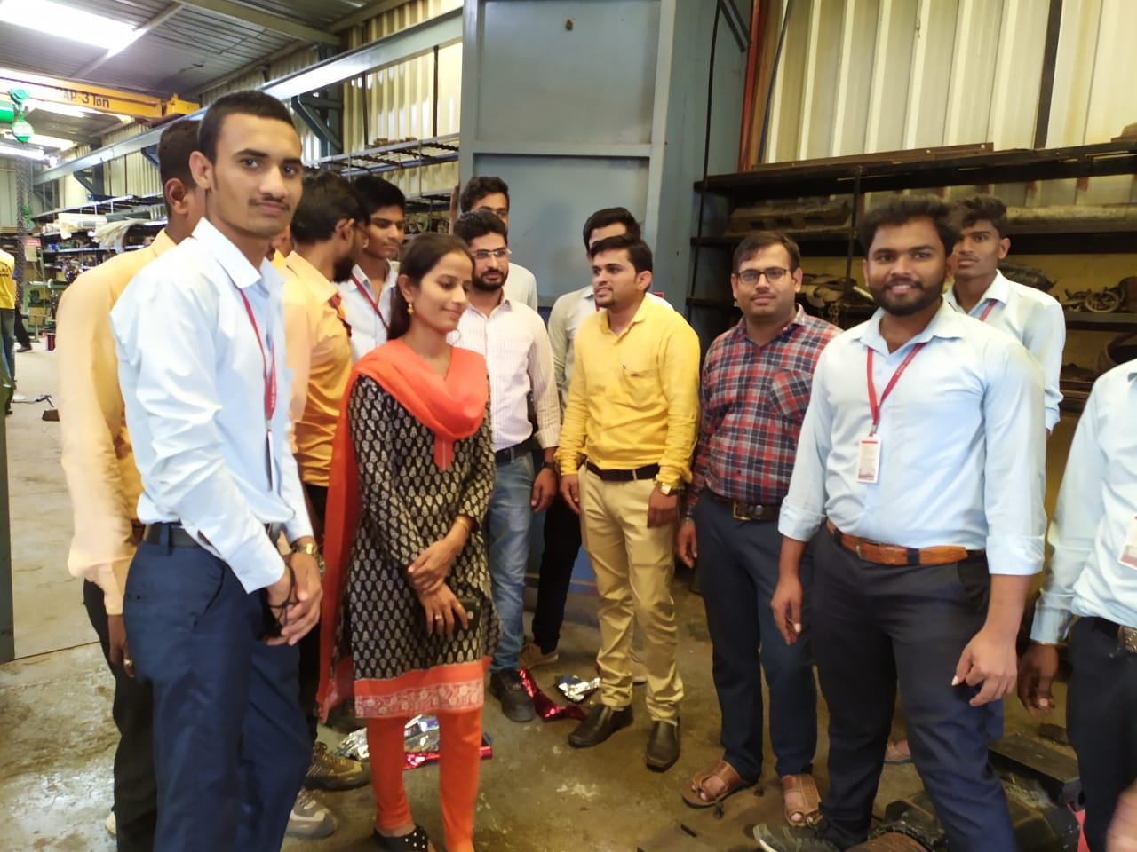

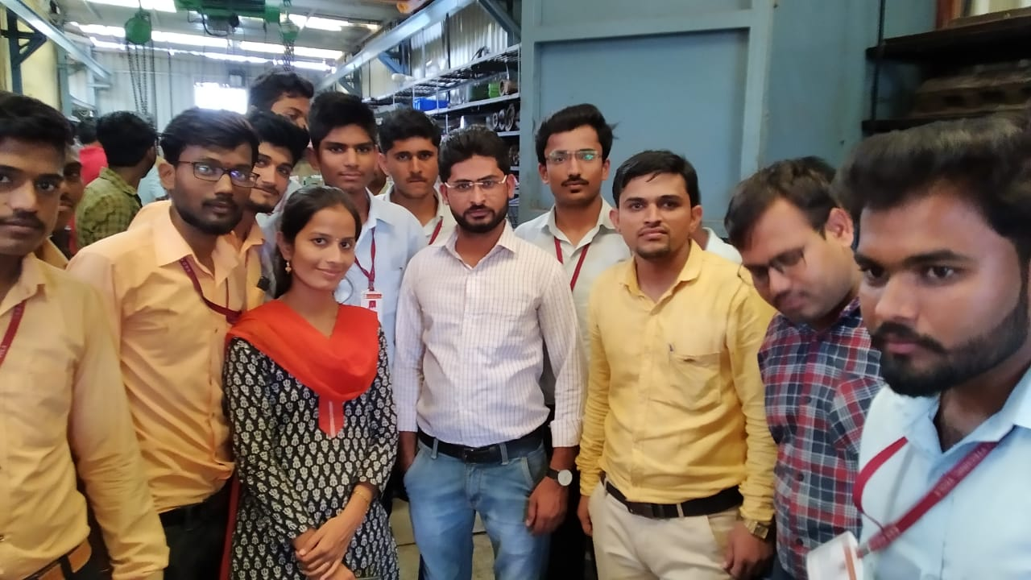

INDUSTRIAL VISIT AT SOLAR POWER PLANT(SHIRDI)

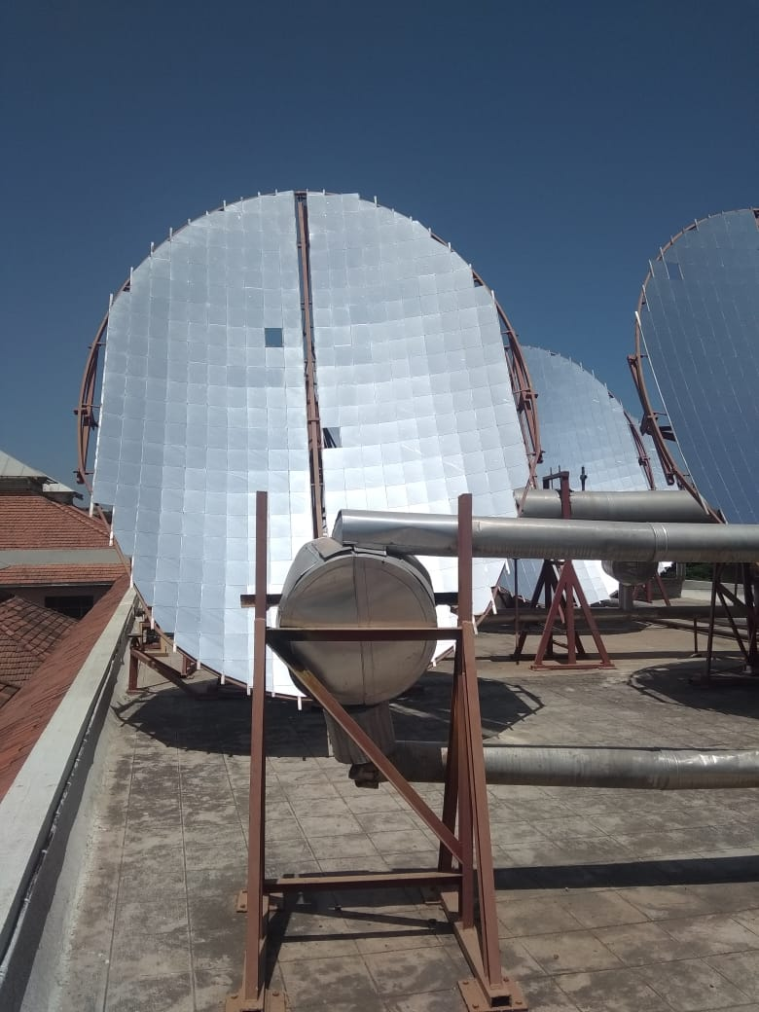

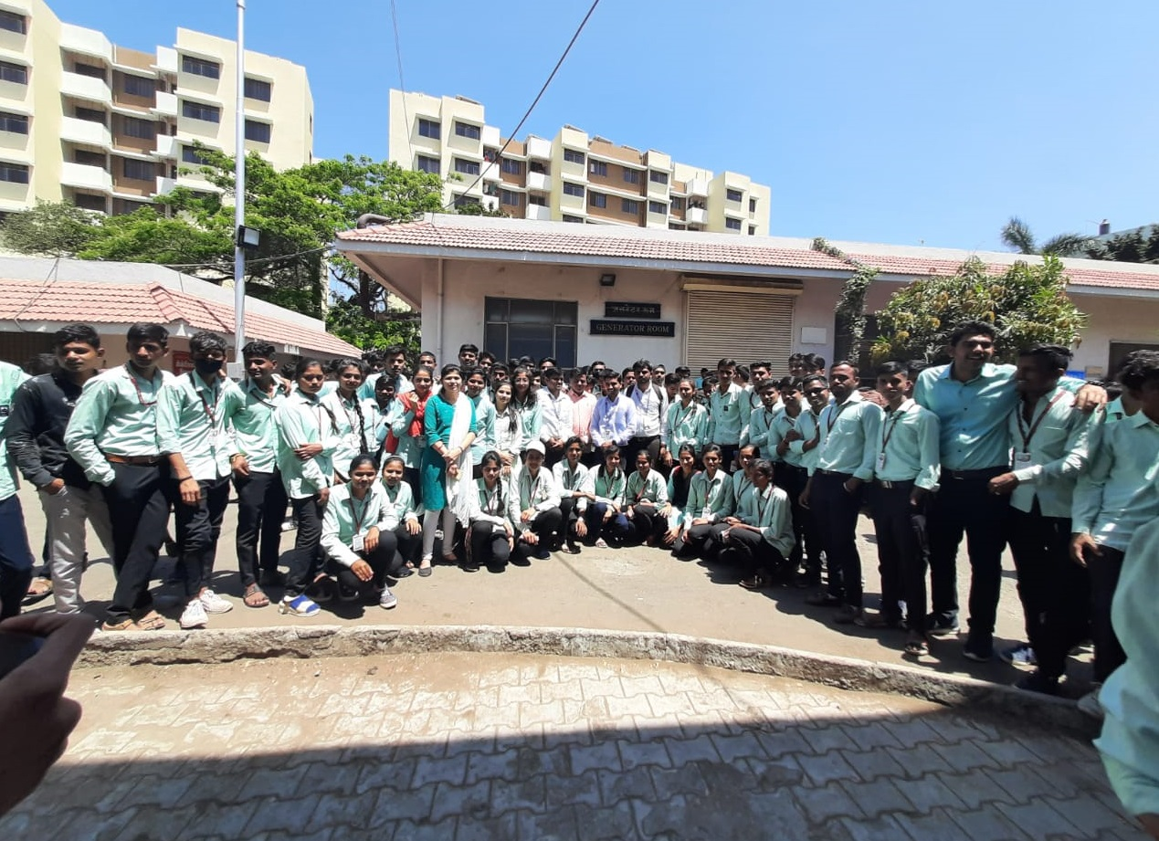

INDUSTRIAL SITE VISIT WATER PURIFICATION PLANT

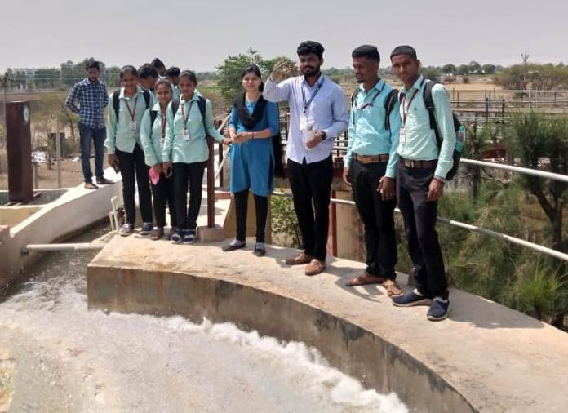

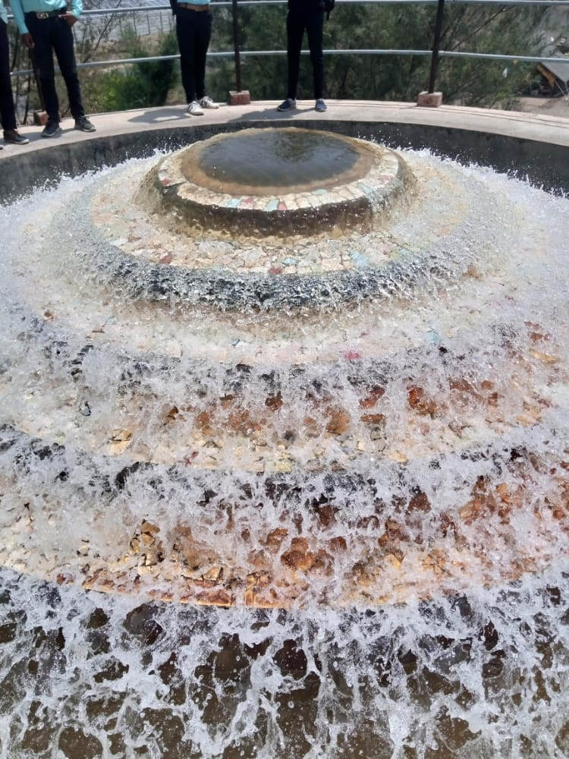

Second Year students of Electrical engineering visited the kotmgoan

INDUSTRIAL VISIT AT WATER PURIFICATION PLANT

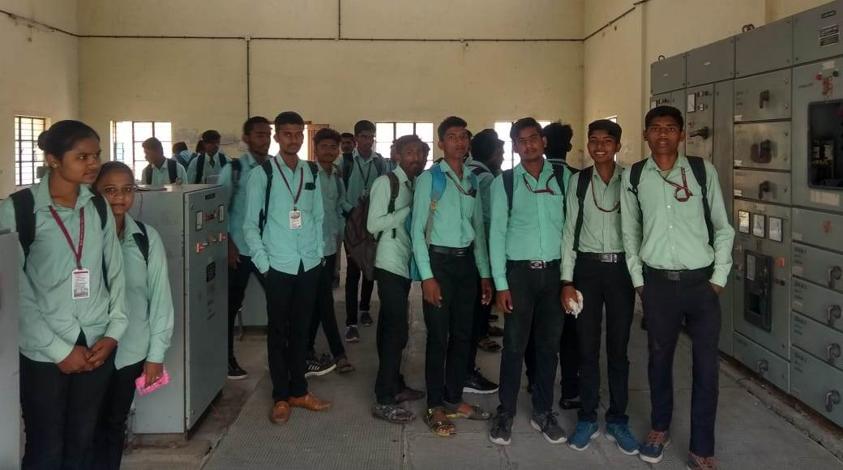
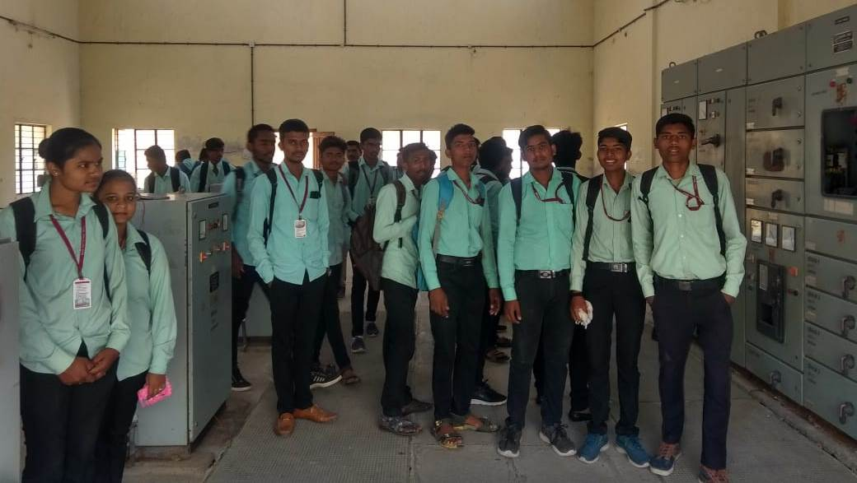

Students of Third Year Electrical Engineering visited the substation by33/11Kv

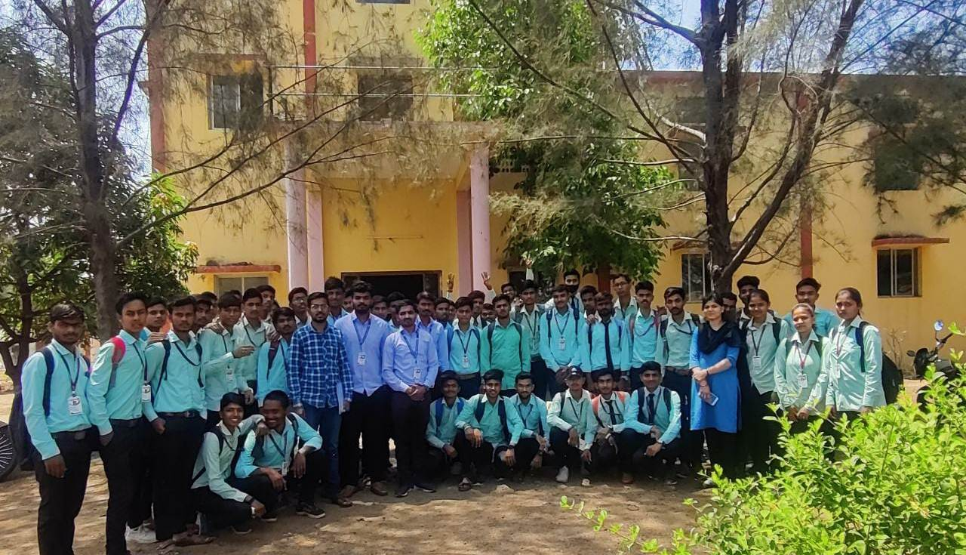
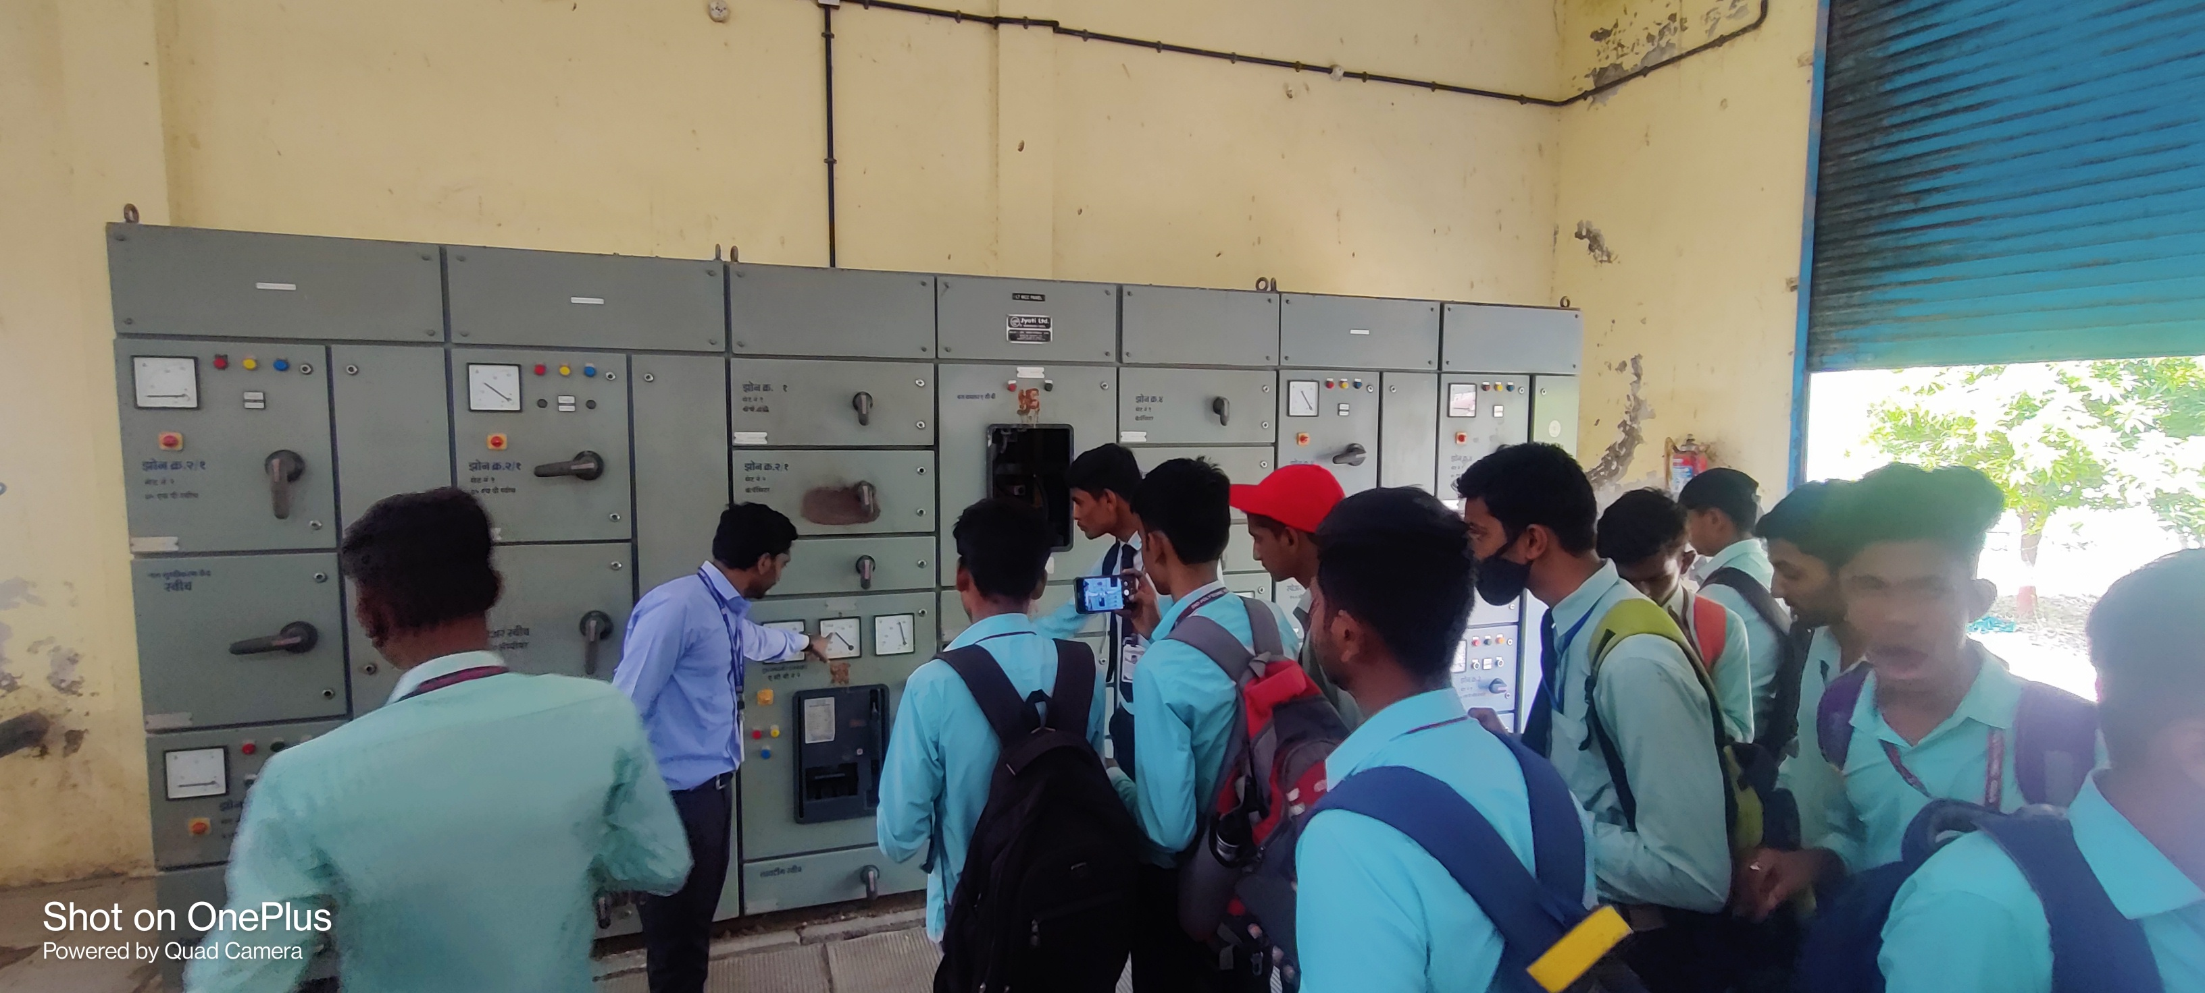

.

STATE LEVEL TECHNICAL EVENT ORAGANISED
“QUIZ-MASTER”

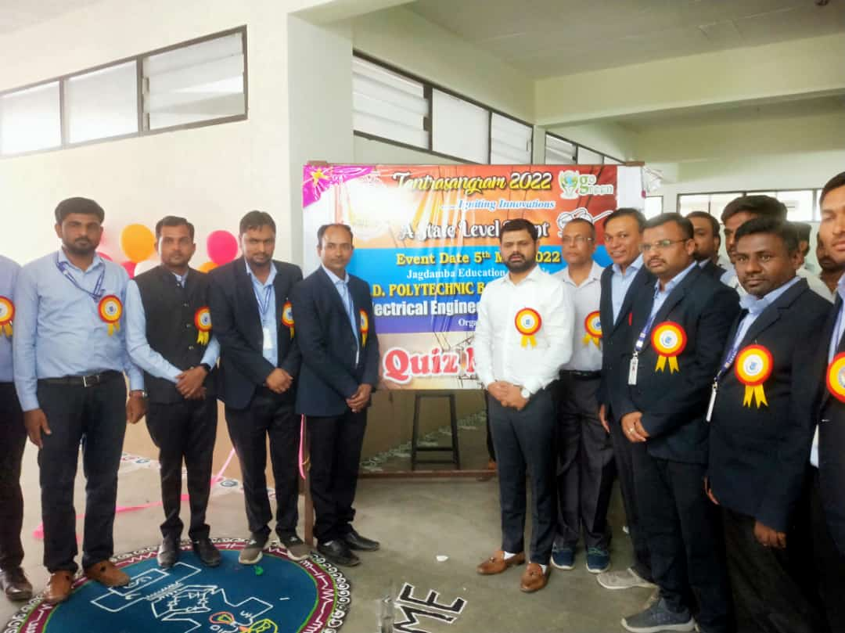
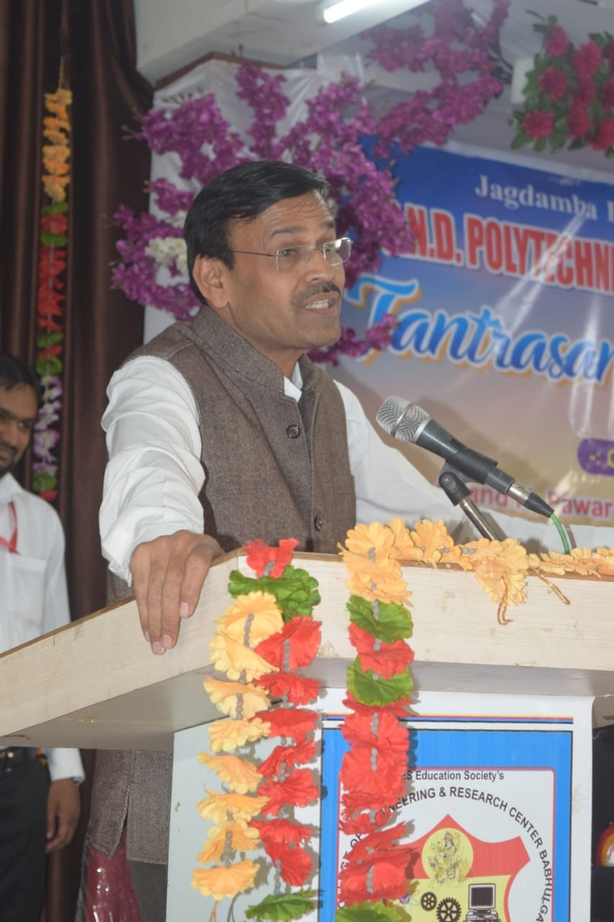

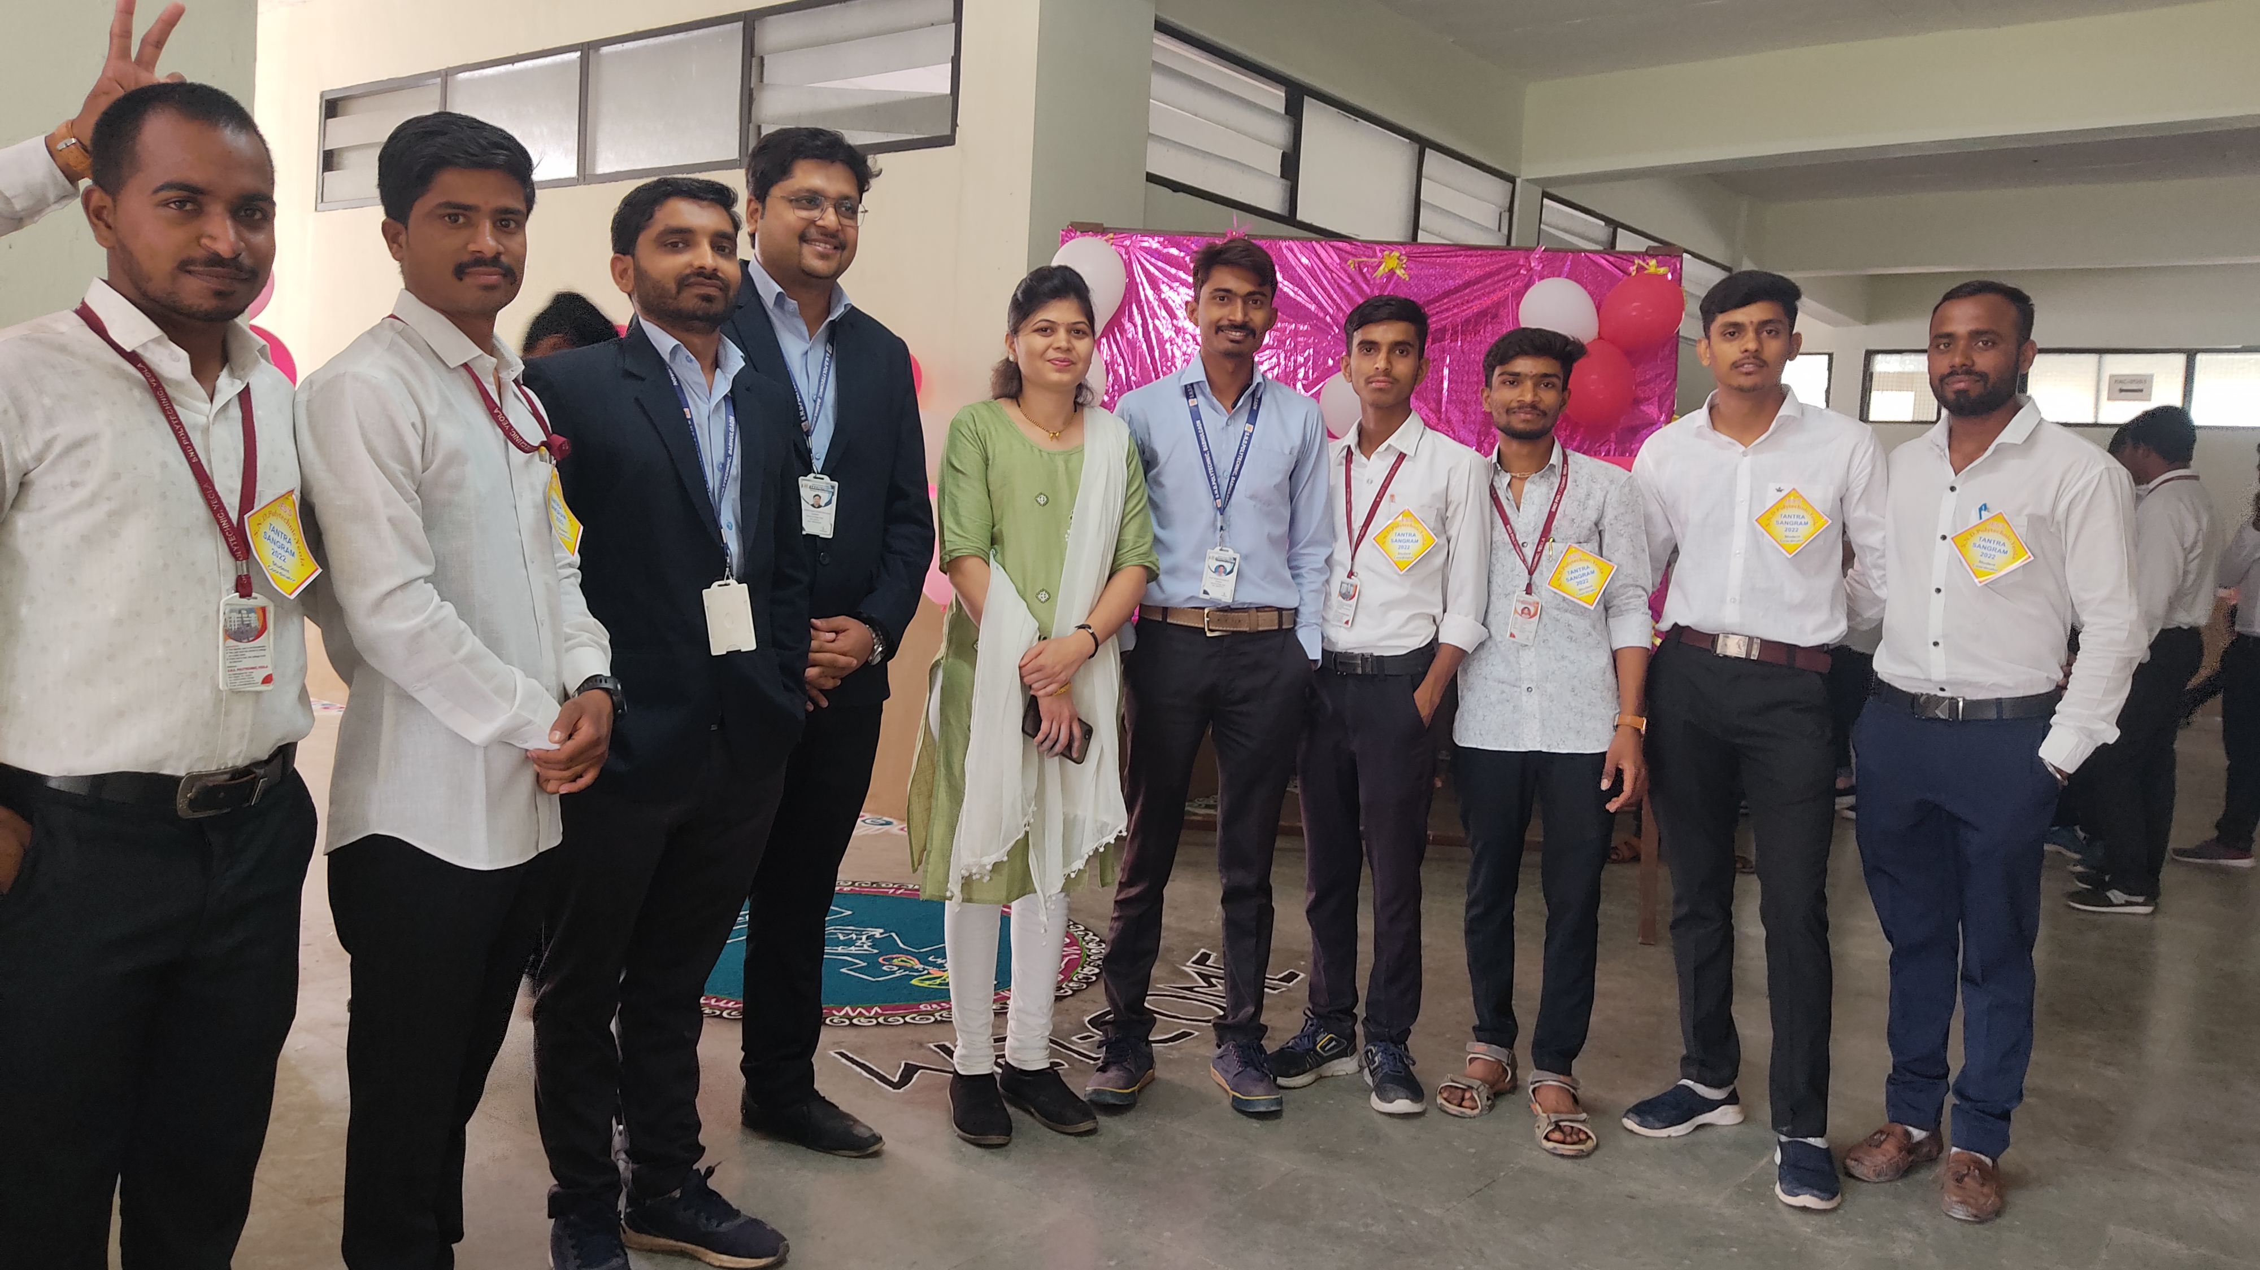
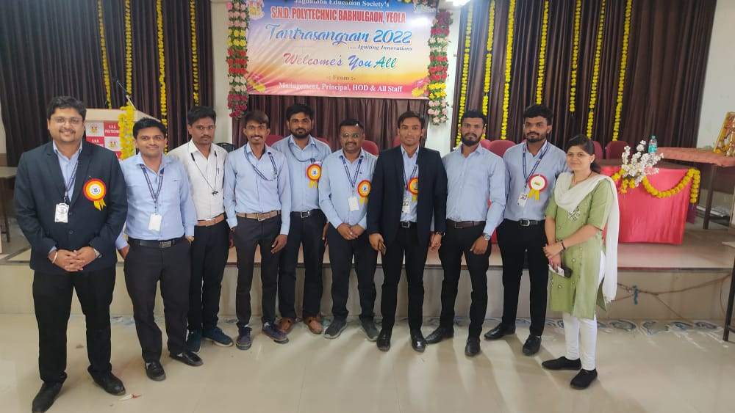

QUIZ MASTER event was organized by Electrical Department of SND POLYTECHNIC YEOLA on 05/05/2022. Students participated in this event.

QUIZ MASTER WINNER

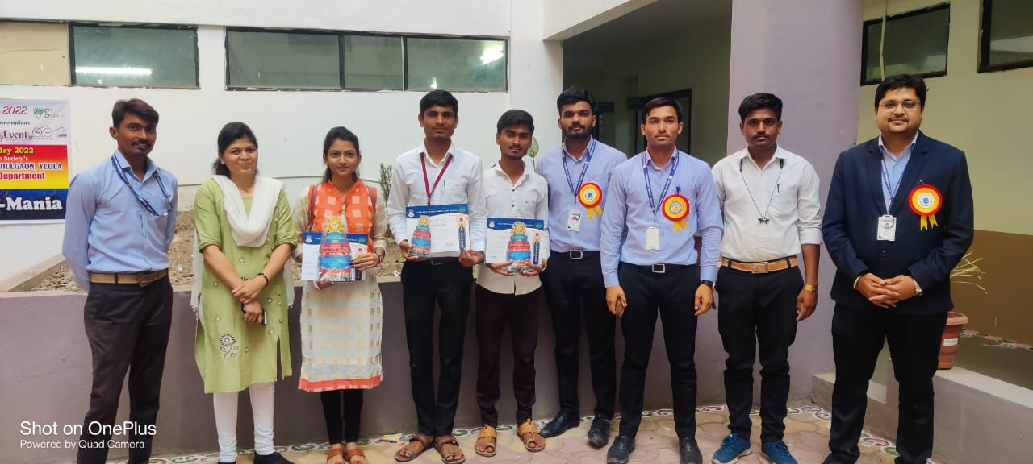

.

GGGHHH

KHJJ

JVHVHVBHVJHBH

SPORTS (2021/2022)

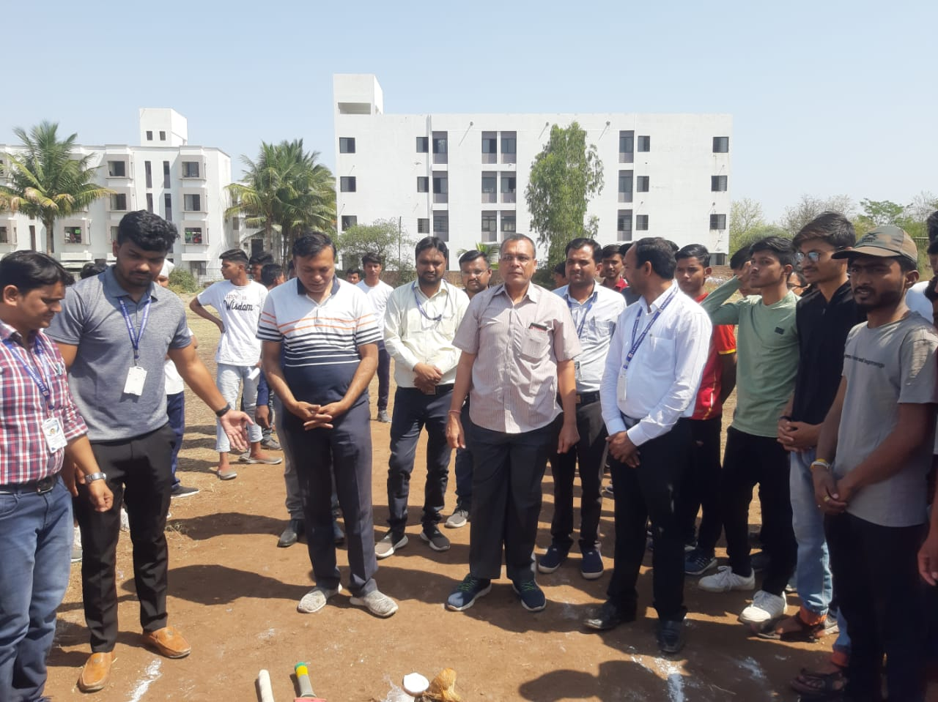
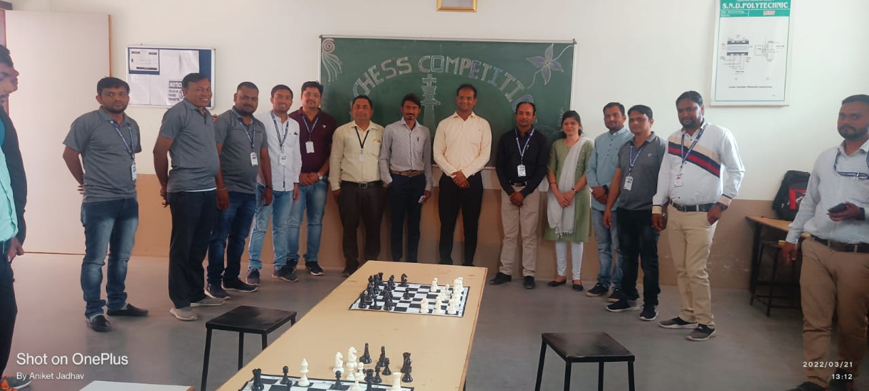

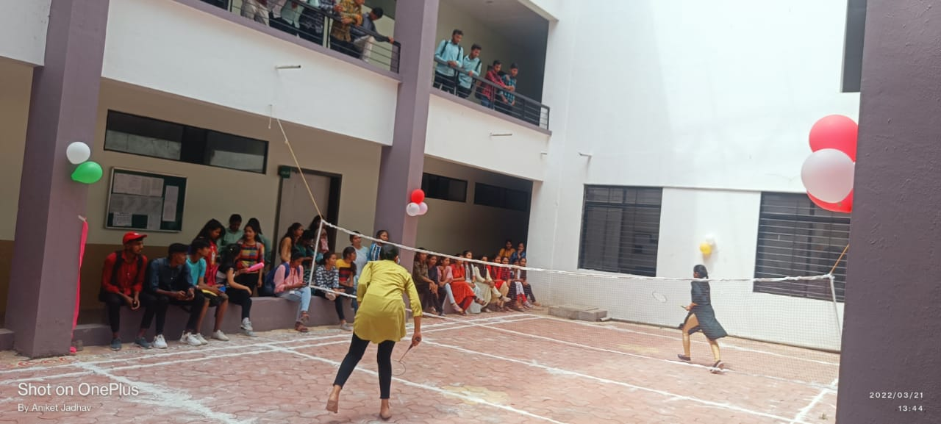

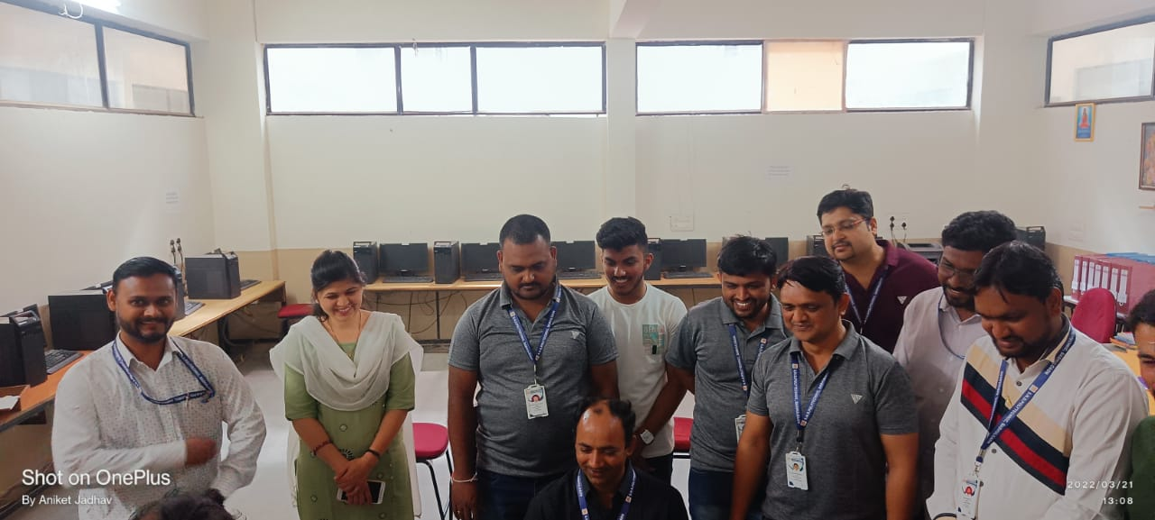

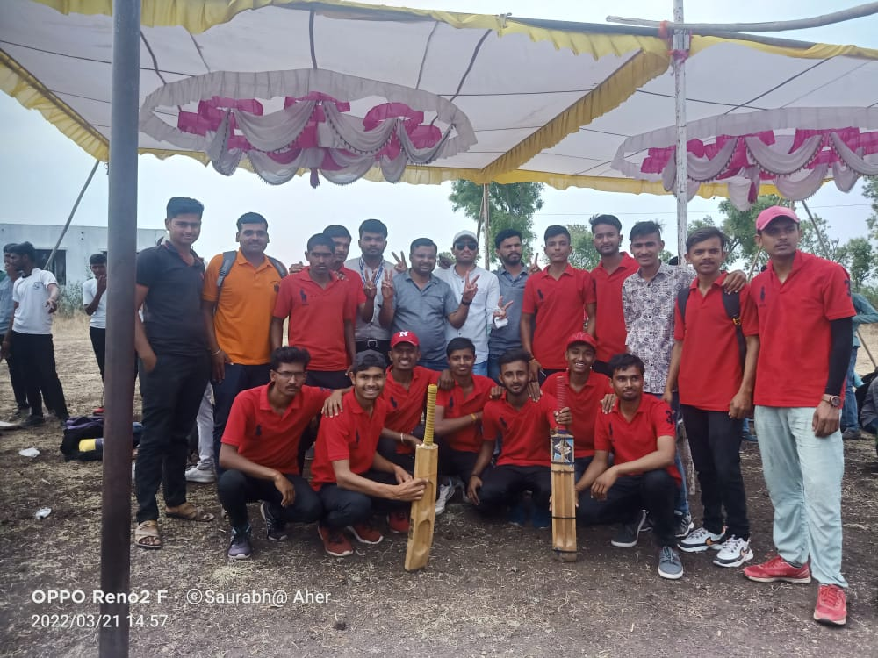

SHIVJAYNTI CELEBRATION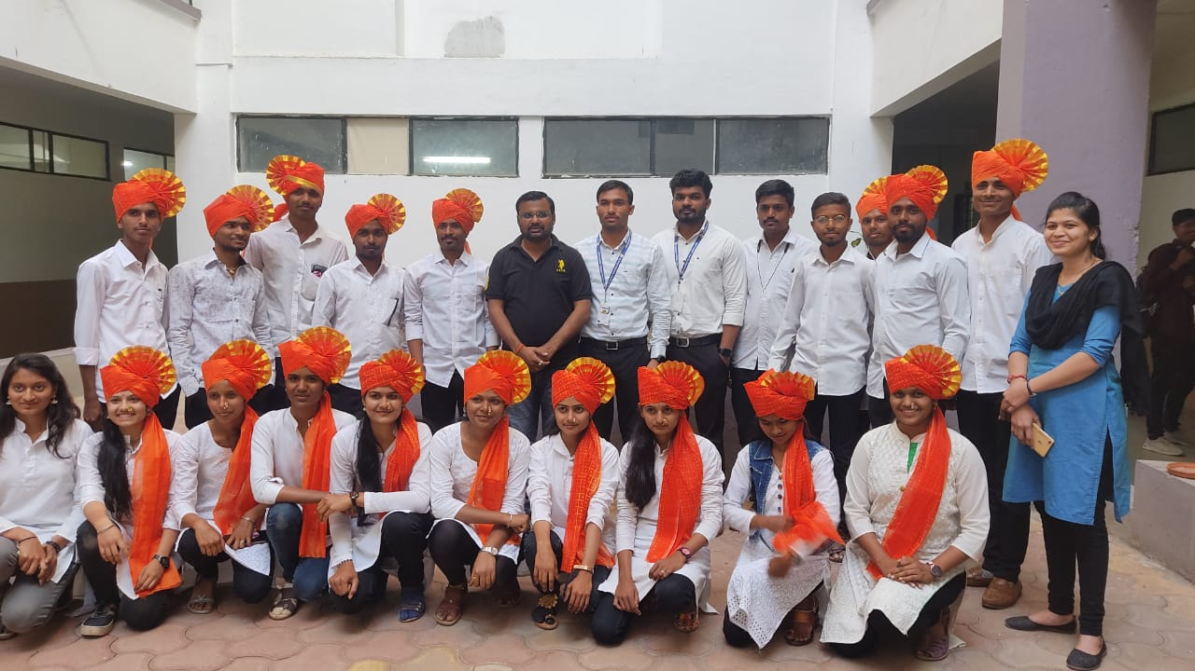

WOMEN’S DAY CELEBRATATION

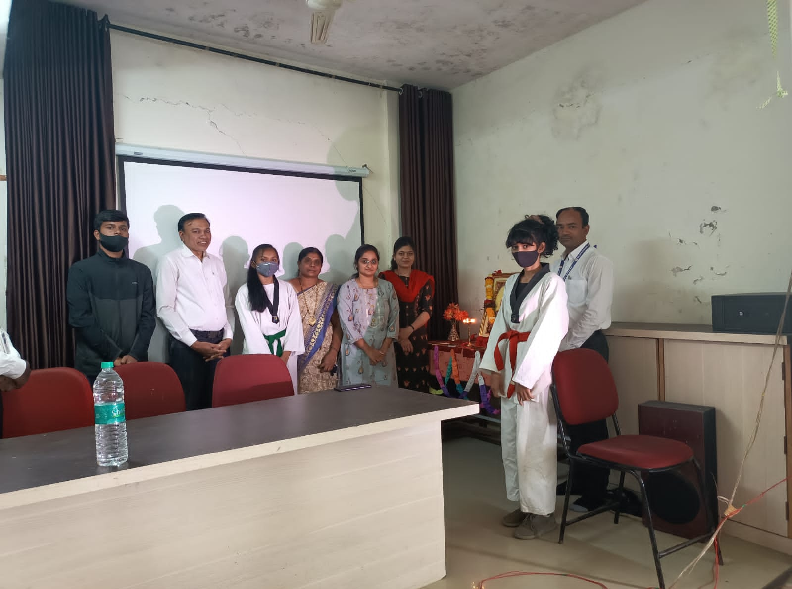

WOMENS DAY CELEBRARION AND TRANING WITH SELF DEFENSE TECHNIQUE

MSBTE W2021/2022 EXAM RESULT ANALYSIS

TYEE STUDENTS TOPPER LIST
NAME OF STUDENT PERCENTAGE
- BODHARE PRASHANT 89%
- SAUNDANE BHARATI 88.80%
- RATHOD YOGITA 88.40%
- THAKARE CHETANA 87.50%
- THOMBARE VAISHNAVI 86.90%

SYEE STUDENTS TOPPER LIST
- JADHAV CHANCHAL 87.25%
- LOKHANDE SACHIN 87.00%
- GHUGE VISHNU 86.88%
- JADHAV KIRAN 86.13%
- THETE TEJAS 84.88%

FYEE STUDENTS TOPPER LIST
- PARDESHI KRISHNA 84.57%
- BAGUL ROSHAN 84.00%
- NEMANE BHAVESH 83.43%

THANK YOU

